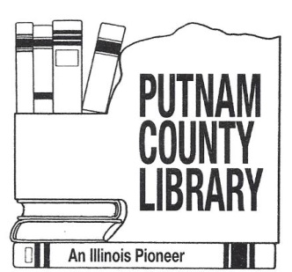
Putnam County Public Library District
Hennepin, Granville, McNabb, Standard, Magnolia, Putnam
Administration
214 North Fourth Street PO Box # 199
Hennepin, IL 61327
Phone and Fax (815)925-7020

Board Meeting Agenda
Monday, October 12, 2026
7:00 p.m.
Hennepin Headquarters

- Call to Order
- Roll Call
- Drew Schlumpf – Marquis Energy
- Correspondence, communications, public comments
- Committee reports
- Consent Agenda - motion to approve consent agenda means that the minutes, librarian’s report and statistics are approved in one motion. Motion: Trustee XXX moves to approve the consent agenda items. Trustee XXX seconds the motion. (action)
  - Secretary’s Report
  - Librarian’s Report and Statistics
  - Financial report
- Approval of bills – (action)
- Unfinished business
  - Unstaffed Libraries & Library Building Plan
  - Hennepin Ceiling Project
- New business
  - Tax Levy Ordinance 26/27-3 – (action)
  - Personnel (5 ILCS 120/2)(c)(1) - (action)
- Other
- Adjournment

